TRIBHUVAN UNIVERSITY
INSTITUTE OF ENGINEERING
KATHMANDU ENGINEERING COLLEGE
KALIMATI, KATHMANDU

Minor Project Report on
AI-Based Smart Security Surveillance System

Submitted to
DEPARTMENT OF ELECTRONICS, COMMUNICATION AND INFORMATION ENGINEERING

Kathmandu Engineering College
Tribhuvan University
Kathmandu, Nepal

Prepared as a complete engineering design for a low-cost implementable minor project

Academic Year: 2025/2026
Prepared with chapter structure aligned to the sample proposal format supplied by the user.

Acknowledgement

We would like to express our sincere gratitude to our project supervisor for providing valuable guidance and support throughout the preparation of this minor project proposal. Their suggestions and technical advice have helped us shape the concept and methodology of the proposed system.
We also extend our thanks to the faculty members of the Department of Electronics, Communication and Information Engineering for providing the resources and academic environment necessary for the completion of this work.
Finally, we would like to thank our friends and colleagues for their encouragement and constructive feedback during the development of this proposal.

Abstract
The AI-Based Smart Security Surveillance System is designed to enhance security monitoring by integrating artificial intelligence, computer vision, and embedded hardware. Traditional surveillance systems rely heavily on manual monitoring, which can be inefficient and prone to human error. This project proposes an automated solution capable of detecting suspicious activities, recognizing individuals, and generating real-time alerts.
The system utilizes an ESP32-CAM to capture live video streams, which are processed using computer vision techniques implemented in Python. The captured frames are analyzed using the YOLOv8 object detection model to identify people and potentially dangerous objects such as weapons. In addition, a face recognition module is used to classify individuals as known or unknown by comparing detected faces with a stored database. The system can also read identification cards using Tesseract OCR, allowing further verification of authorized individuals.
A PIR motion sensor connected to an Arduino Uno triggers the camera and detection process when motion is detected, helping reduce unnecessary processing and improving efficiency. When suspicious activity, unauthorized access, or dangerous objects are detected, the system sends alerts and activates warning devices such as buzzers or alarms through a relay module. All events are recorded with timestamps using a DS3231 RTC module and stored in a database for monitoring and analysis.
Furthermore, the system provides a web-based monitoring dashboard built with Django, where users can view live camera feeds, detection results, and security logs. This integrated approach combines hardware sensors, artificial intelligence, and web technologies to create a cost-effective and intelligent surveillance solution.
Overall, the proposed system improves security by enabling real-time detection, automated alerts, and centralized monitoring, making it suitable for applications such as campuses, offices, restricted areas, and smart buildings.

Table of Contents

CHAPTER 1 - Introduction
1.1 Background
1.2 Problem Statement
1.3 Objectives
1.4 Scope
1.5 Applications
CHAPTER 2 - Literature Review
CHAPTER 3 - Related Theory
3.1 IoT Systems
3.2 ESP32-CAM
3.3 YOLOv8 Object Detection
3.4 Optical Character Recognition (OCR)
3.5 Cloud Notification Systems
CHAPTER 4 - Feasibility Study
4.1 Financial Feasibility
4.2 Technical Feasibility
CHAPTER 5 - Methodology
5.1 System Block Diagram
5.2 Algorithm
5.3 Flowchart
5.4 System Architecture
CHAPTER 6 - Expected Results
CHAPTER 7 - References
Appendix A - Hardware Pin Mapping
Appendix B - Example Codes

CHAPTER 1 - Introduction

1.1 Background
Educational institutions increasingly require automated monitoring systems that are accurate, contactless, and auditable. Conventional attendance methods such as paper registers, manual security logs, or standalone biometric devices either consume staff time or provide limited contextual information. A smart entrance monitoring system that captures both direction of movement and student identity can improve security while reducing manual work.
The rapid growth of embedded IoT hardware and lightweight vision systems now allows low-cost platforms such as the ESP32-CAM to act as event-triggered edge devices. Rather than executing all AI computation locally, the edge node can capture data and forward it to a more capable server where modern algorithms such as YOLOv8 and Tesseract OCR process images in near real time. This hybrid architecture is especially suitable for university minor projects because it balances affordability, implementability, and technical depth.

1.2 Problem Statement
At college entry points, security personnel often need to determine who entered, when they entered, whether they exited, and whether the individual is authorized. Manual observation is error-prone and difficult to maintain continuously. Existing low-cost camera systems record video but do not automatically understand the event, verify student identity, or update attendance records. There is therefore a need for a low-cost surveillance and attendance platform that can automatically detect entry and exit direction, capture the student and ID card image, verify the identity against a database, log the event, and notify authorized personnel when an unknown person is detected.

1.3 Objectives
• To design a low-cost IoT-enabled surveillance system using ESP32-CAM, IR sensors, RTC, OLED, buzzer, and relay control.
• To detect entry or exit direction by analyzing the trigger sequence of two IR sensors placed at the doorway.
• To capture event images and transmit them to a server using Wi-Fi.
• To use YOLOv8 to detect the person, face, and ID-card region from captured images.
• To use Tesseract OCR to extract the student name or ID number from the visible card.
• To verify extracted identity data against a student database and automatically record attendance.
• To alert administrators or security staff when an unknown person is detected.
• To provide a realistic academic design that can be implemented by engineering students within a minor project budget.

1.4 Scope
The proposed system is intended for a single entrance gate or door in a college building. It is designed to monitor movement one person at a time under moderate lighting conditions. The project scope includes local sensing, event-driven image capture, server-side AI inference, database verification, logging, and notifications. Full-scale deployment across multiple buildings, large cloud orchestration, or highly reliable legal-grade identity verification is outside the initial scope.

1.5 Applications
• College building entry and exit attendance monitoring
• Laboratory or library access logging
• Restricted-room monitoring for staff-only or student-only areas
• Visitor alerting and security assistance
• Prototype platform for smart campus automation

CHAPTER 2 - Literature Review
Recent embedded surveillance systems commonly use a layered design in which an inexpensive edge node handles sensing and triggering while a more capable server performs deep learning inference. ESP32-CAM based academic prototypes are popular because the device combines a microcontroller, camera interface, and Wi-Fi connectivity on a single compact platform. However, the onboard processor is not suitable for running larger object detection models such as YOLOv8 at acceptable accuracy and speed, so server-side inference is preferred.
Object detection is now widely used to identify people, faces, cards, helmets, and safety objects in surveillance scenes. YOLO-family detectors are favored in applied engineering projects due to their single-stage architecture and good trade-off between speed and detection accuracy. For identity extraction from printed cards, OCR remains attractive because it avoids the complexity and privacy concerns of full face recognition, while still enabling automatic attendance when the card is clearly visible.
In smart campus and access-control studies, cloud-connected notification systems play a central role because detection alone is insufficient unless the event can be logged and presented to security or administration staff. Database-backed event logging provides traceability, while mobile or dashboard alerts support quick response to unknown-person events. The present design adopts these established ideas but keeps the architecture simple enough for a minor project and affordable enough for student implementation

CHAPTER 3 - Related Theory

3.1 IoT Systems
An IoT system typically consists of sensing devices, an edge or gateway layer, a communication layer, and an application layer. In the proposed project, the IR sensors and RTC represent the sensing layer, the ESP32-CAM acts as the edge node, Wi-Fi serves as the communication layer, and the server, database, and dashboard form the application layer. The main benefit of the IoT approach is that data are captured at the physical site while intelligence and storage are available remotely or on a campus server.

3.2 ESP32-CAM
The ESP32-CAM is a compact module based on the ESP32 microcontroller with integrated Wi-Fi and a camera interface, usually paired with an OV2640 image sensor. It is suitable for low-cost embedded imaging tasks because it can trigger image capture, compress the frame to JPEG, and transmit it over HTTP or MQTT. It also supports GPIO pins for sensors and actuators, although the number of freely available pins is limited because several pins are reserved by the camera.

3.3 YOLOv8 Object Detection
YOLOv8 is a modern single-stage deep learning detector that predicts object classes and bounding boxes in one forward pass. In this project, YOLOv8 is used at the server to detect the student body or face and optionally the ID-card region. The detector helps reject empty frames and supports localization of the card region for OCR. A compact variant such as YOLOv8n is appropriate for a student project because it is lighter to train and faster to deploy on a laptop or GPU-enabled PC.

3.4 Optical Character Recognition (OCR)
OCR converts an image of text into machine-readable characters. Tesseract OCR is an open-source OCR engine that works well for structured printed text when the input image is first preprocessed. In the proposed system, the server crops the detected card area, converts it to grayscale, enhances contrast, applies thresholding or denoising, and then sends the cleaned image to Tesseract. The output text is matched against known student IDs or names in the database.

3.5 Cloud Notification Systems
A notification subsystem bridges the surveillance event and the human operator. Once the database verification step is complete, the server generates one of two outcomes: an attendance event for a matched student, or an alert event for an unknown person. Notifications can be delivered through email, Telegram bot, web dashboard, SMS gateway, or push notification service. For a minor project, Telegram or email is usually the most practical choice because it is simple to integrate and has no dedicated hardware cost.

CHAPTER 4 - Feasibility Study

4.1 Financial Feasibility
The proposed system is financially feasible because most of the hardware is low-cost and reusable. The most economical architecture uses the ESP32-CAM as the edge acquisition device and an existing laptop or desktop computer as the server. This avoids the cost of an edge GPU platform. The software stack is primarily open-source, including Arduino IDE, Python, OpenCV, Ultralytics YOLOv8, Tesseract OCR, SQLite or MySQL, and Flask/FastAPI.
Component | Typical Unit Cost (NPR) | Qty | Total (NPR) | Remarks
ESP32-CAM with OV2640 | 1,300 | 1 | 1,300 | Main edge device
IR obstacle sensors | 250 | 2 | 500 | Direction sensing
DS3231 RTC module | 300 | 1 | 300 | Timestamp backup
0.96 in OLED SSD1306 | 500 | 1 | 500 | User feedback
Buzzer | 100 | 1 | 100 | Audio alert
1-channel relay module | 250 | 1 | 250 | Door control
12 V solenoid lock / servo | 1,200 | 1 | 1,200 | Gate actuation option
5 V / 2 A adapter + regulator | 700 | 1 | 700 | Power supply
Jumper wires, breadboard, misc. | 600 | 1 | 600 | Interfacing
Laptop/PC as server | Existing | 1 | 0 | Use available college PC
Estimated project hardware total: approximately NPR 5,450 if an existing PC is used as the processing server. This is well within the range of many academic minor projects.

4.2 Technical Feasibility
The system is technically feasible because the project separates tasks according to device capability. The ESP32-CAM can reliably handle sensor reading, direction logic, image capture, Wi-Fi communication, and simple actuator control. The server performs the heavier tasks: YOLOv8 detection, OCR preprocessing, database lookup, and notifications. Each module uses mature libraries, and the complete system can be integrated with commonly available tools and programming environments.
• ESP32-CAM supports JPEG capture and HTTP client communication.
• IR sensors provide simple and inexpensive entry/exit sequence detection.
• YOLOv8n can run on a mid-range laptop CPU for prototype-scale inference, with faster performance on GPU.
• Tesseract OCR is open-source and practical for printed ID cards after preprocessing.
• SQLite or MySQL can store student data and event logs with minimal setup.
• Telegram bot, email SMTP, or a web dashboard can handle real-time alerts.

CHAPTER 5 - Methodology

5.1 System Block Diagram

Figure 5.1: System block diagram of the proposed surveillance system.
The block diagram shows how the sensing, edge control, communication, AI processing, database, and alerting layers are connected. The ESP32-CAM is the central field node. It receives movement information from the IR sensors and time information from the RTC, captures an image, and then interacts with the OLED, buzzer, and relay based on the server decision.

5.2 Hardware Circuit Diagram

Figure 5.2: Simplified hardware circuit diagram with major signal and power connections.

5.3 Flowchart

Figure 5.3: Operational flowchart from sensing to logging or alert generation.

5.4 AI Processing Pipeline

Figure 5.4: AI processing pipeline used at the server.

5.5 IoT System Architecture
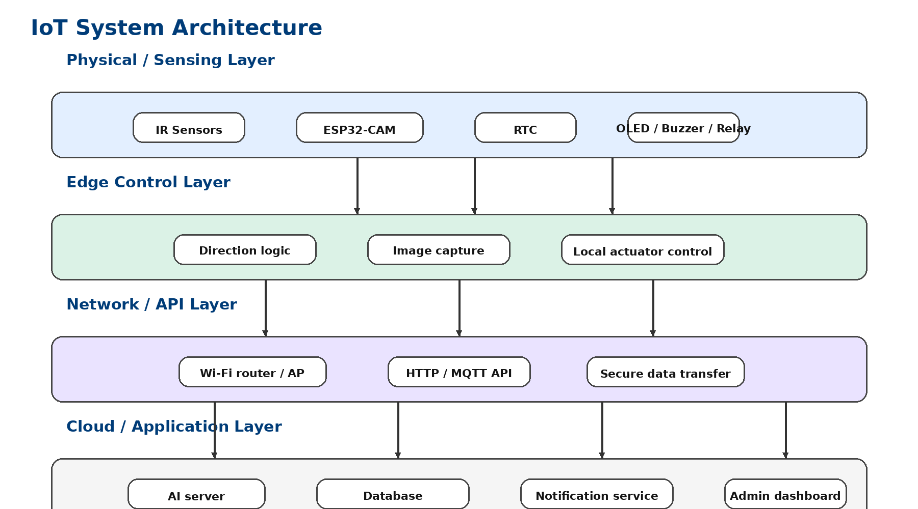
Figure 5.5: Layered IoT system architecture.

5.6 Gantt Chart
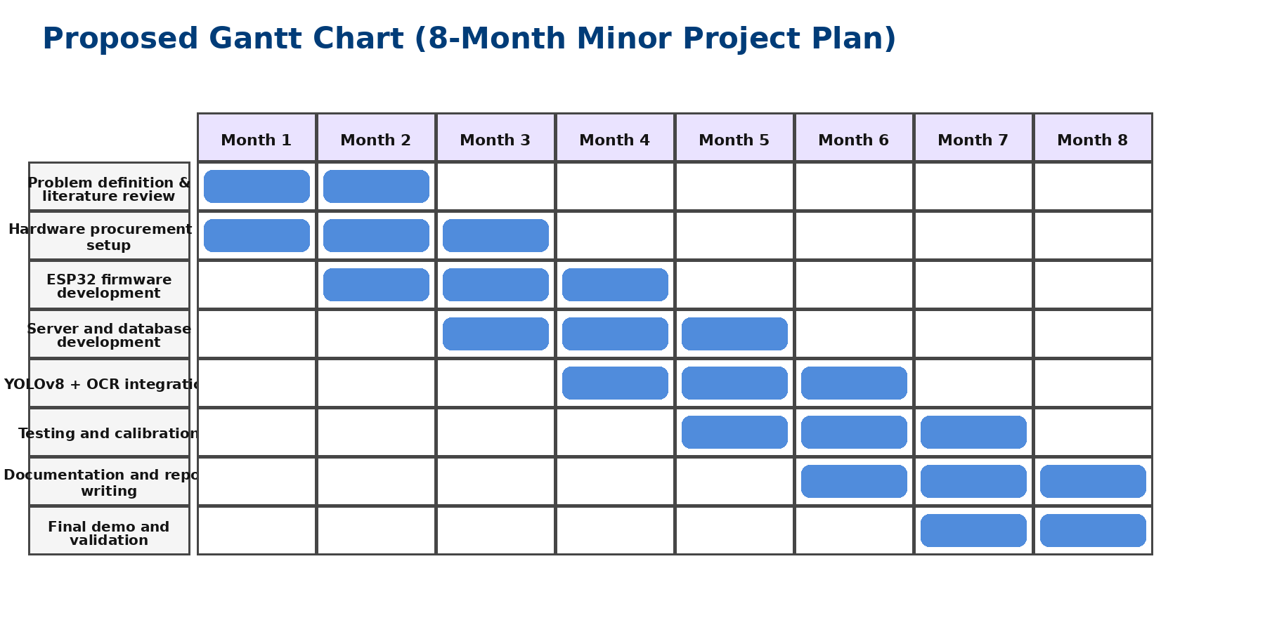
Figure 5.6: Proposed eight-month project schedule.

5.7 System Architecture Description
The overall architecture is divided into three logical layers. The edge device layer consists of the ESP32-CAM, IR sensors, RTC, OLED, buzzer, and relay. The AI processing layer consists of a Python server running image preprocessing, YOLOv8 inference, OCR, and event classification. The cloud or application layer consists of the student database, event log, notification engine, and dashboard. This partitioning keeps hardware cost low while still enabling advanced AI.

5.8 Algorithms

Entry/Exit detection using IR sensors
1. Wait until any IR sensor changes from idle to active.
2. If IR1 is triggered before IR2 within a valid timing window, classify as Entry.
3. If IR2 is triggered before IR1 within a valid timing window, classify as Exit.
4. Ignore incomplete sequences and apply a debounce timer to avoid repeated triggers from the same person.
5. Store the classified direction as metadata attached to the captured image.

Image capture and transmission
1. On valid direction event, trigger ESP32-CAM frame capture.
2. Compress the frame as JPEG to reduce transfer size.
3. Read current date and time from DS3231 RTC or NTP backup.
4. Build a multipart HTTP POST or binary upload packet containing image, timestamp, and direction.
5. Send the packet to the server endpoint and wait for acknowledgment.

Person detection using YOLOv8
1. Receive image at server.
2. Resize image to detector input size and normalize pixel values.
3. Run YOLOv8 inference to detect person, face, and optionally card.
4. Reject image if no person is detected.
5. Pass face/card regions to the next stage for OCR preprocessing.

ID card text extraction using Tesseract OCR
1. Crop probable ID-card region.
2. Convert to grayscale and apply contrast enhancement.
3. Use thresholding, denoising, and perspective correction where needed.
4. Run Tesseract OCR with suitable page segmentation mode.
5. Post-process text using regex patterns and string cleaning to isolate student ID or name.

Database verification
1. Search exact or fuzzy match of extracted ID in the student table.
2. If a valid record exists, classify as Authorized Student.
3. If no valid record exists, classify as Unknown Person.
4. Create an attendance/event record containing timestamp, direction, extracted text, and image path.

Notification system
1. If Authorized Student, optionally send a normal attendance notification or only log silently.
2. If Unknown Person, send alert message with image to security/admin.
3. Update dashboard, buzzer state, and optional relay action according to event type.
4. Archive event data for audit and future analysis.

5.9 Hardware Design
The hardware node is designed around one ESP32-CAM module installed near the entrance. Two IR sensors are fixed on the door frame at a small spacing to determine movement direction. The DS3231 RTC provides accurate timestamp backup. The OLED gives immediate local status such as 'Entry Logged' or 'Unknown Person'. The buzzer gives brief audio feedback. A relay module can energize a door lock or drive a motor control stage for a gate.

Recommended hardware specifications:
• ESP32-CAM: AI Thinker ESP32-CAM with OV2640 camera, 4 MB PSRAM preferred.
• IR sensors: 2 x infrared obstacle sensors or break-beam sensors, 5 V supply.
• RTC: DS3231 I2C module with coin-cell backup.
• OLED: 0.96 inch SSD1306 I2C display, 128 x 64 pixels.
• Buzzer: 5 V active buzzer or transistor-driven passive buzzer.
• Relay: 1-channel 5 V opto-isolated relay module.
• Door lock: 12 V solenoid lock or SG90/MG996R servo depending on gate mechanism.
• Power: 5 V / 2 A regulated supply for node electronics; separate higher-current supply for lock if used.

Appendix A - GPIO Pin Mapping
ESP32-CAM Pin | Function | Connected Module | Notes
5V | Power input | 5 V regulated supply | Use stable 2 A source
GND | Ground | All modules | Common reference ground
GPIO13 | Digital input | IR Sensor 1 output | Entry/exit sequence input
GPIO12 | Digital input | IR Sensor 2 output | Entry/exit sequence input
GPIO14 | Digital output | Relay IN | Controls lock or gate driver
GPIO15 | Digital output | Buzzer | Short beep on result
GPIO2 | I2C SDA | OLED + DS3231 | Shared I2C bus
GPIO4 | I2C SCL | OLED + DS3231 | Shared I2C bus
UART U0R/U0T | Programming | FTDI programmer | Used during firmware upload
OV2640 interface | Camera | Built-in | Reserved for camera signals

4. Software Architecture (Detailed Design)

Edge Device Layer
• Initialize camera, Wi-Fi stack, RTC, OLED, buzzer, and GPIOs.
• Continuously sample IR sensors with debounce logic.
• Classify movement direction using sensor sequence timing.
• Capture JPEG image after valid trigger.
• Package metadata: timestamp, direction, device ID, event sequence number.
• Upload image and metadata to server endpoint.
• Receive response and actuate buzzer, OLED, and optional relay.

AI Processing Layer
• Server receives image through REST API.
• OpenCV preprocessing resizes, denoises, and optionally corrects perspective.
• YOLOv8 validates the presence of a person and localizes card region.
• Tesseract OCR extracts the printed ID or name.
• String cleaning and pattern matching improve OCR reliability.
• Business logic determines whether the event is authorized or unknown.

Cloud / Application Layer
• Student database stores enrollment ID, name, department, and permitted access fields.
• Event log table stores time, direction, extracted text, authorization result, and image path.
• Notification module sends messages to admin or security.
• Dashboard provides query, filtering, and image review interface.
• Attendance export can be generated as CSV or PDF.

7. System Workflow
1. A student approaches the entrance gate and interrupts one IR sensor.
2. The second IR sensor triggers shortly afterward, allowing the ESP32-CAM to classify the movement as entry or exit based on sequence order.
3. The ESP32-CAM reads the RTC timestamp and captures a JPEG image containing the person and student card.
4. The image and metadata are transmitted over Wi-Fi to the processing server.
5. The server preprocesses the image and runs YOLOv8 to confirm the presence of a person and optionally isolate the visible ID-card region.
6. The cropped card image is passed to Tesseract OCR for text extraction.
7. The extracted student ID or name is cleaned and compared with the student database.
8. If a valid match is found, the system records an attendance event with direction and time, updates the OLED display, and optionally unlocks the door briefly.
9. If no valid match is found, the system stores the image as an alert event and sends a security notification with the event details.
10. All events remain available in the dashboard and database for later review.

CHAPTER 6 - Expected Results
• Automatic entry and exit logging for authorized students.
• Accurate timestamping of events using RTC-backed time records.
• Near real-time notifications for unknown or unverified persons.
• Improved campus security through image evidence and database-backed logging.
• Reduced manual attendance effort at monitored doors.
• A reusable academic platform for future smart campus research.
The expected operational result is a working prototype capable of monitoring one controlled doorway under indoor lighting with moderate traffic. System performance will depend on camera placement, ID-card visibility, network strength, and OCR quality. In practice, multiple test iterations will be required to tune sensor spacing, image framing, and OCR preprocessing.

8. Future Improvements
• Integrate face recognition after obtaining necessary privacy approval.
• Support multi-camera deployment using a central campus server.
• Move some inference tasks to edge AI hardware such as ESP32-S3 or NVIDIA Jetson.
• Add mobile app monitoring for security officers.
• Introduce anti-tailgating logic for multiple people entering together.
• Integrate with smart campus ERP or academic attendance systems.
• Add dashboard analytics such as peak-hour counts, frequent unknown alerts, and access
trends.

Appendix B - Example Codes

ESP32-CAM (Arduino) example

Python server example

CHAPTER 7 - References
• J. Redmon et al., works on real-time object detection and later YOLO-family developments.
• Ultralytics documentation for YOLOv8 deployment and inference workflows.
• R. Smith, 'An Overview of the Tesseract OCR Engine,' ICDAR.
• Espressif Systems, ESP32 and ESP32-CAM related hardware documentation.
• DS3231 RTC module and SSD1306 OLED module technical datasheets.
• OpenCV and Flask official documentation for image processing and API development.
Redmon, J., et al., 'You Only Look Once: Unified Real-Time Object Detection', IEEE CVPR.
[2] Ultralytics, 'YOLOv8 Documentation', Ultralytics.
[3] Smith, R., 'An Overview of the Tesseract OCR Engine', IEEE.
[4] Espressif Systems, 'ESP32-CAM Technical Reference Manual'.
[5] Tanenbaum, A., 'Computer Networks', Pearson.
[6] Rajkumar Buyya, 'Internet of Things: Principles and Paradigms', Elsevier.
[7] Goodfellow, I., Bengio, Y., Courville, A., 'Deep Learning', MIT Press.

